



Virtual Machine in the Azure Portal
LAB MANUAL

Disclaimer: The content is curated from online/offline resources and used for educational purpose only
Create a Windows Virtual Machine in the Azure Portal
Objective:
• To understand the concept of Virtual Machines in cloud computing.
• To create and configure a Windows Virtual Machine using the Azure Portal.
• To learn how to deploy and manage a virtual machine in Microsoft Azure.
Equipment Required:
• Computer or Laptop
• Internet Connection
• Web Browser (Google Chrome / Microsoft Edge / Firefox)
• Microsoft Azure Account
Prerequisites:
• Basic knowledge of cloud computing
• An active account on Microsoft Azure
• Access to the Azure Portal
Problem Statement:
Virtual machines allow users to run operating systems and applications in the cloud without needing physical hardware. In this lab, students will create a Windows Virtual Machine using the Azure Portal and understand the basic configuration settings required for deployment.
Procedure:
Step 1: Login to Azure Portal
- Open a web browser.
- Navigate to the Azure Portal.
- Sign in using your Microsoft Azure account credentials.
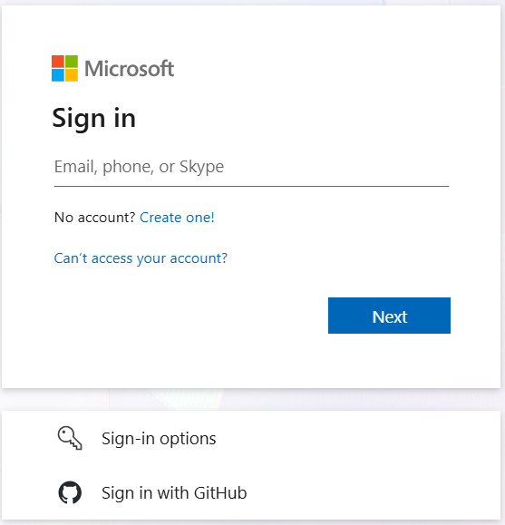

Step 2: Start Virtual Machine Creation
- In the Azure Portal search bar, type Virtual Machines.
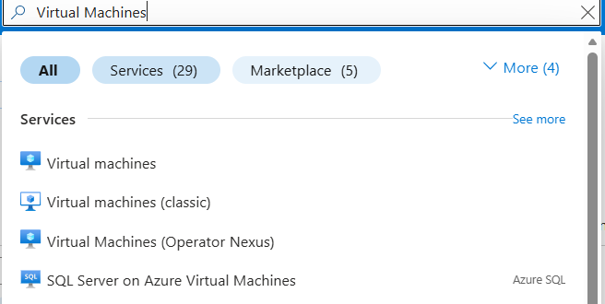
- Select Virtual Machines from the services list.

- Click Create.

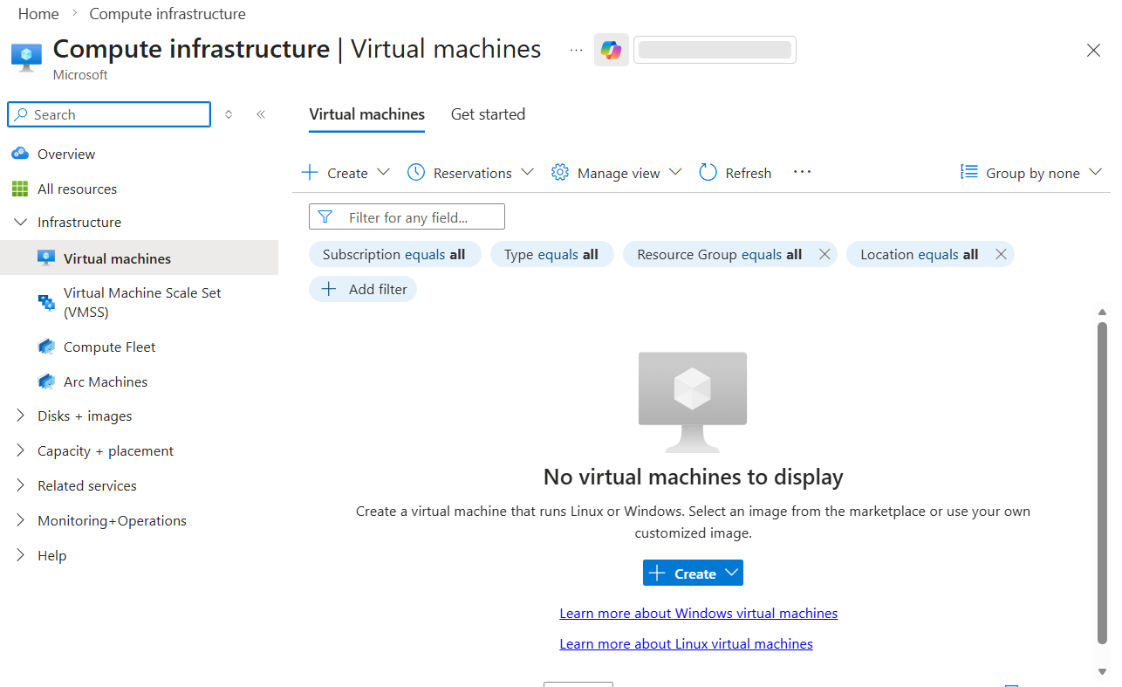
- Select Azure Virtual Machine.
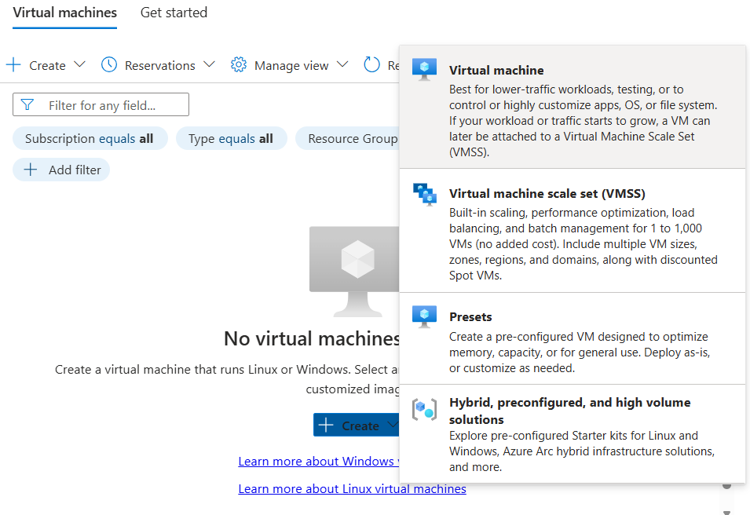

Step 3: Configure Basic Settings
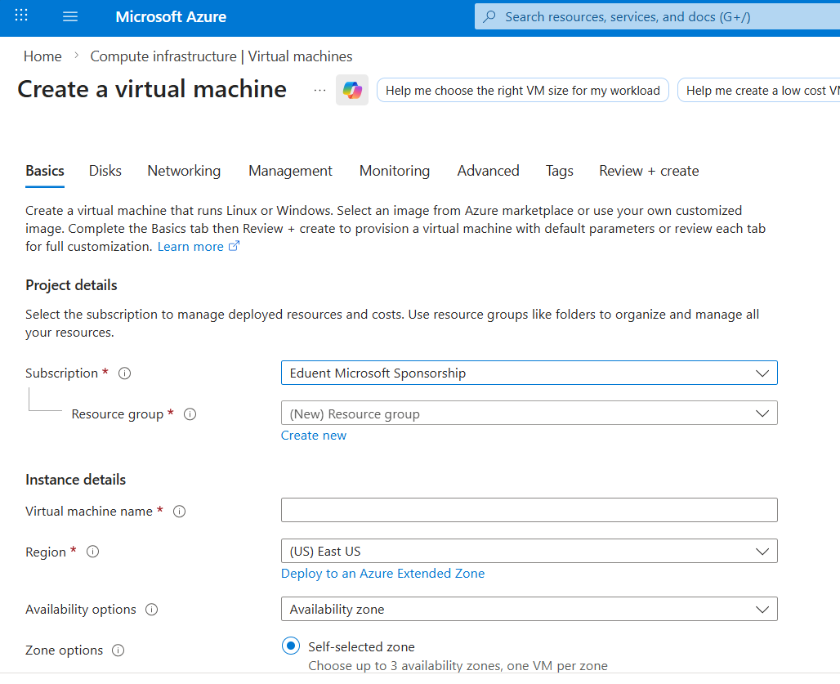
Fill in the following details:
• Subscription: Select your Azure subscription.
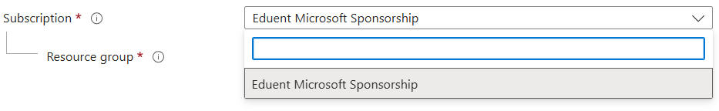
• Resource Group: Create a new resource group or select an existing one.
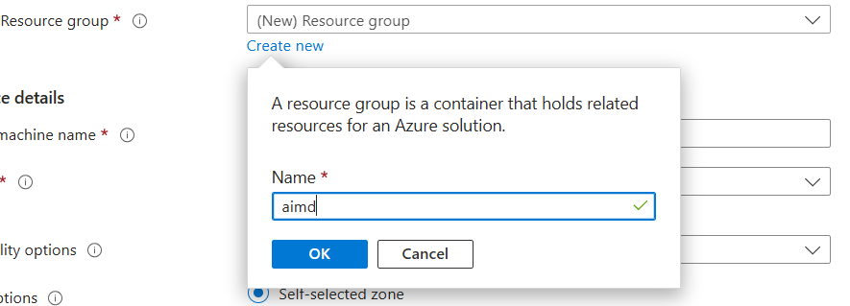
Now select :
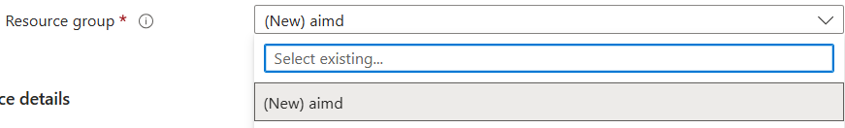
• Virtual Machine Name: Enter a name (e.g., VM-Windows-Lab).
• Region: Select a region close to your location.
• Image: Choose Windows Server 2019 Datacenter or Windows 11.
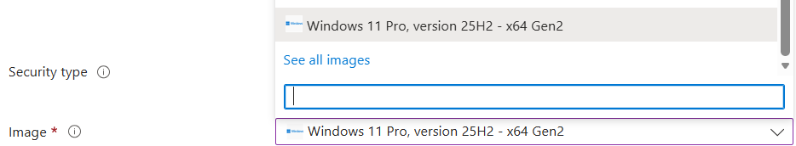
• Size: Select an available VM size (e.g., Standard B1s).
• Username: Enter administrator username.
• Password: Create a secure password.
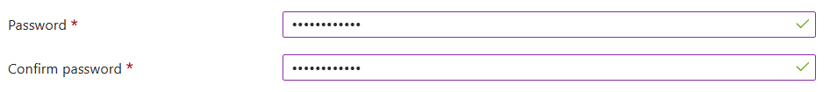
• Inbound Ports: Allow RDP (3389) to enable remote access.
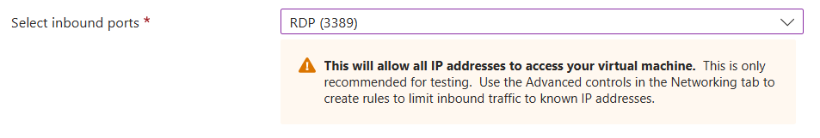
Click Next to proceed.
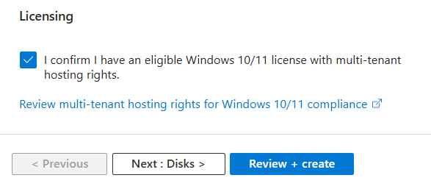
Step 4: Configure Additional Settings
- Review default settings for:
  - Disks
  - Networking
  - Management
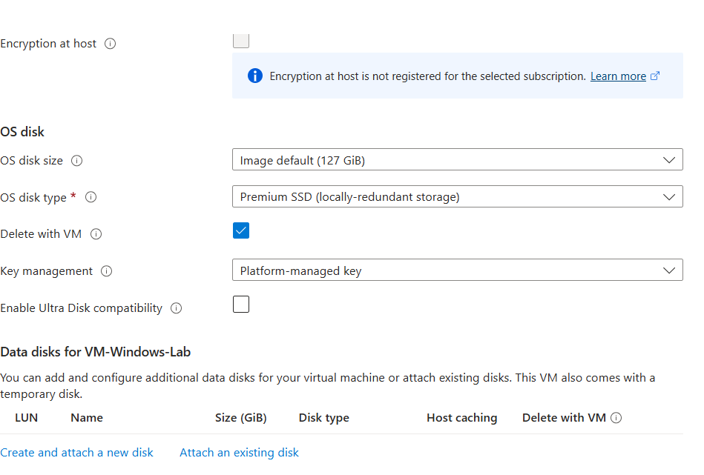
- Keep the default settings if no changes are required.
- Click Review + Create.
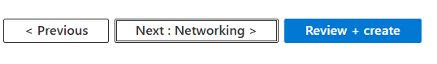
Step 5: Deploy the Virtual Machine
- Azure validates the configuration.
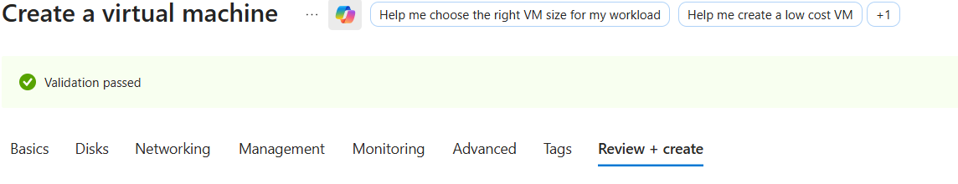
- Click Create to start deployment.
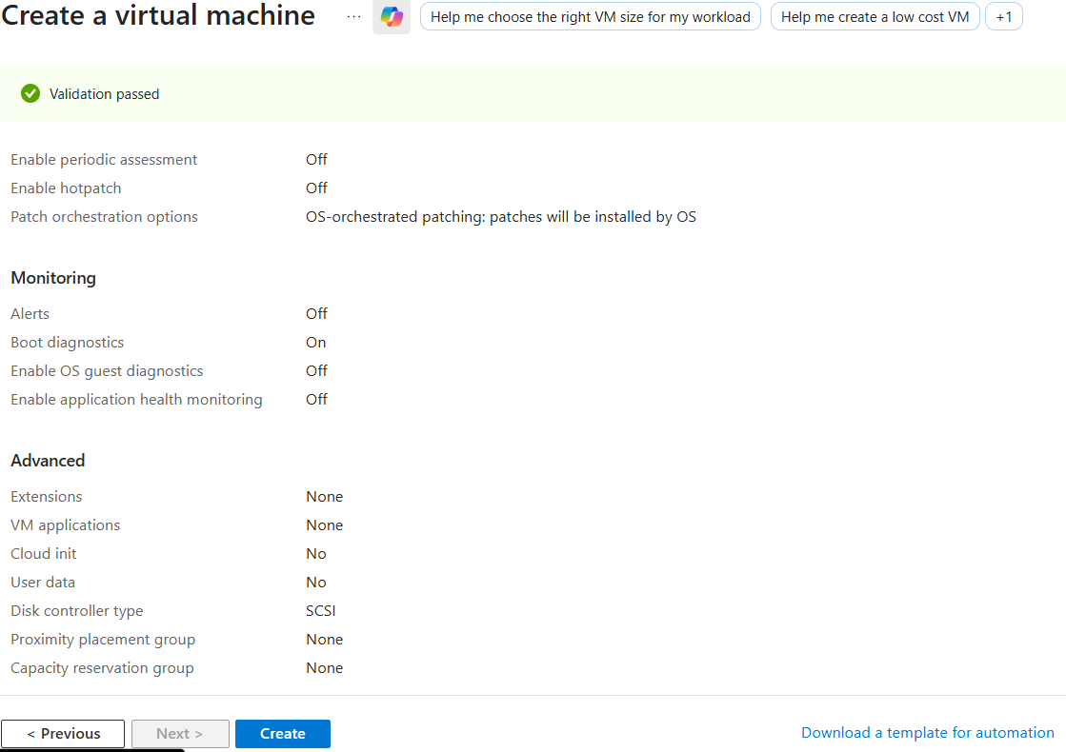
- Wait for the deployment process to complete.
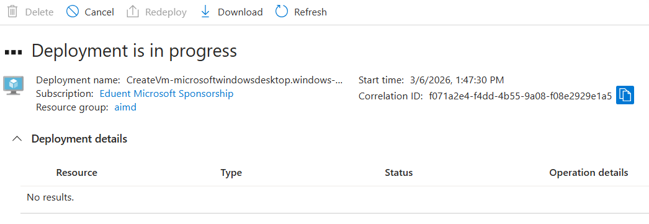
Final,

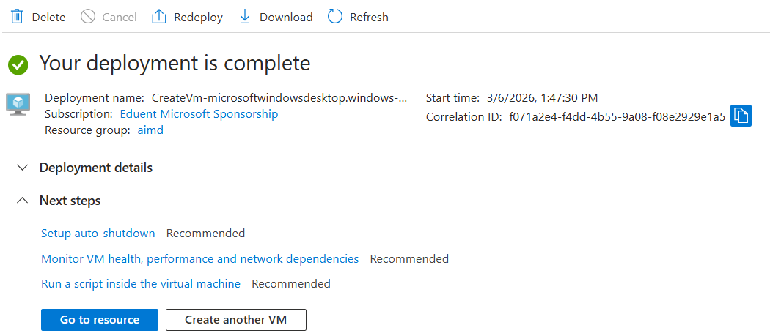
Step 6: Connect to the Virtual Machine
- After deployment, open the Virtual Machine Overview page.
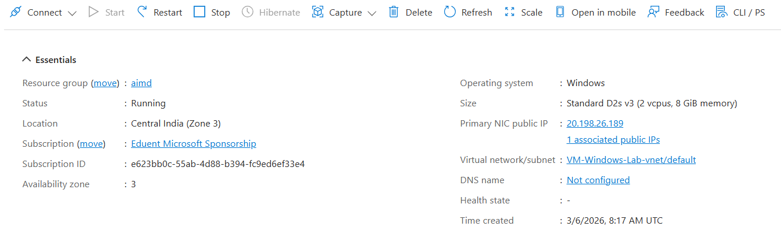
- Click Connect.
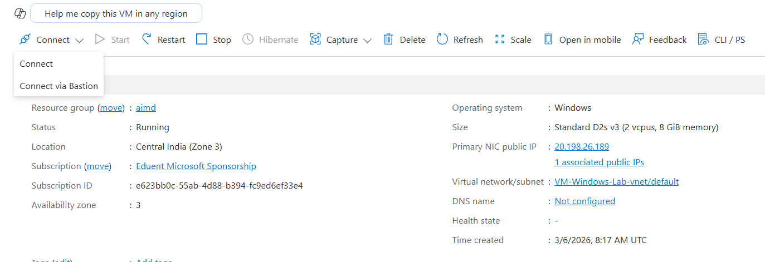
- Select RDP (Remote Desktop Protocol).
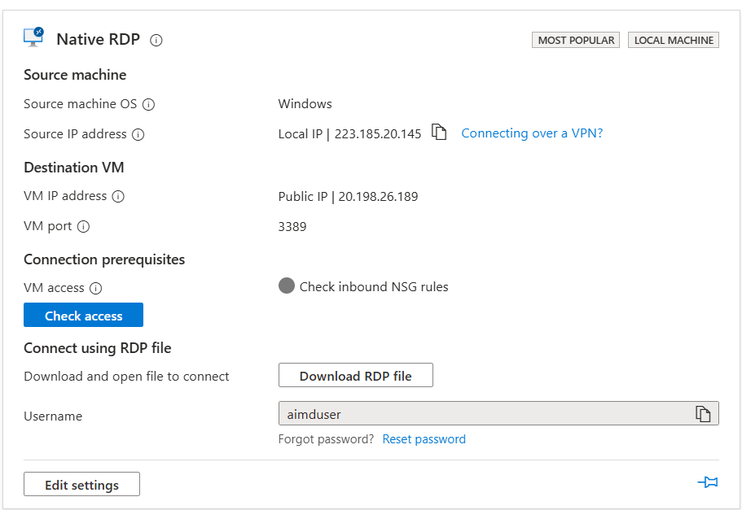
- Download the RDP file.
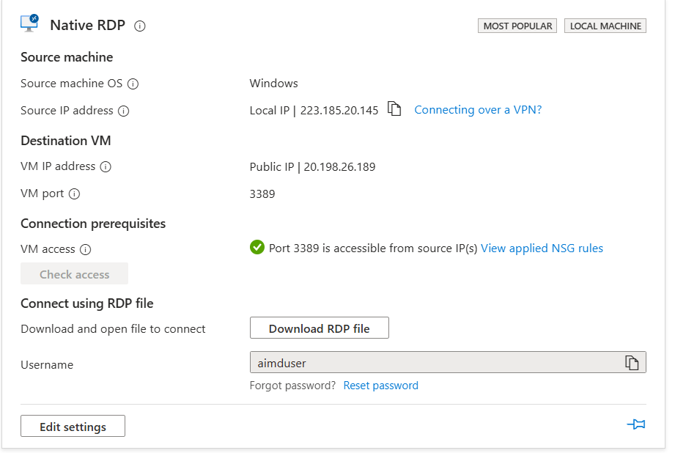
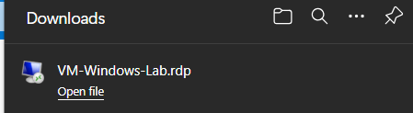
Run this file.
- Open the file and enter the username and password created earlier.
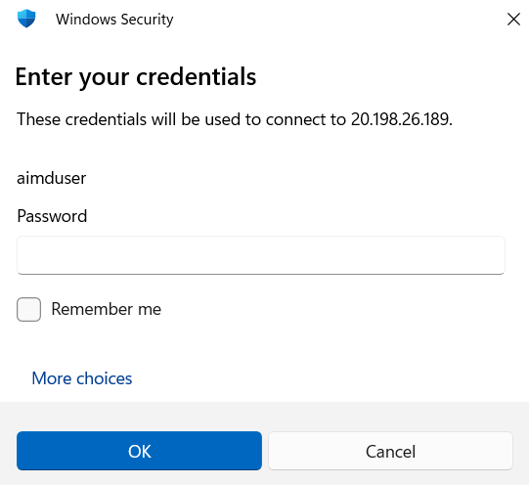
- The Windows desktop of the virtual machine will open.
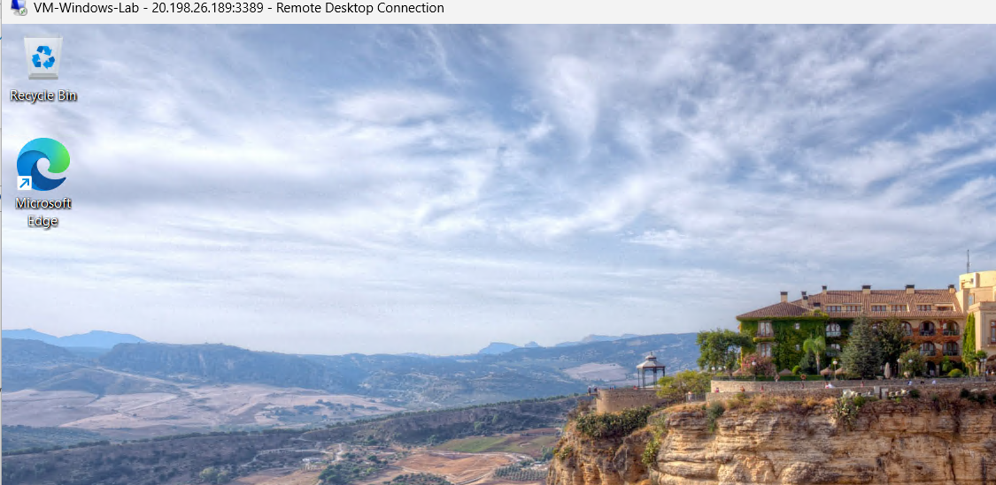

Conclusion:
In this lab, we successfully created and deployed a Windows Virtual Machine using the Azure Portal. We configured the required settings, deployed the VM, and connected to it using Remote Desktop Protocol (RDP). This lab demonstrates how cloud platforms provide virtual computing resources without requiring physical hardware.

